**Student Have To Prepare Report In Format**

1. Add Task Description
2. Attach Screenshot Of Output.
3. Describe Widget/Algorithm Used In Task
4. Add Report In Your Task Zip File

**Sample Example :**

1. **Task Description**
2. This project implements a **shopping cart feature** in a React application, enabling users to manage selected items efficiently. It provides functionalities to add items, remove items, and update item quantities dynamically, using a clean and interactive UI. Below is a detailed description of the features, technologies, and sub-technologies used:
3. **Task Output Screenshot**

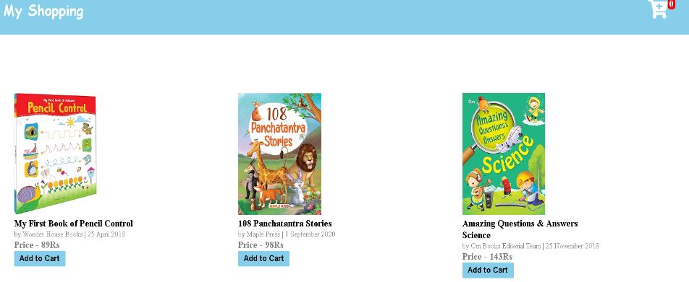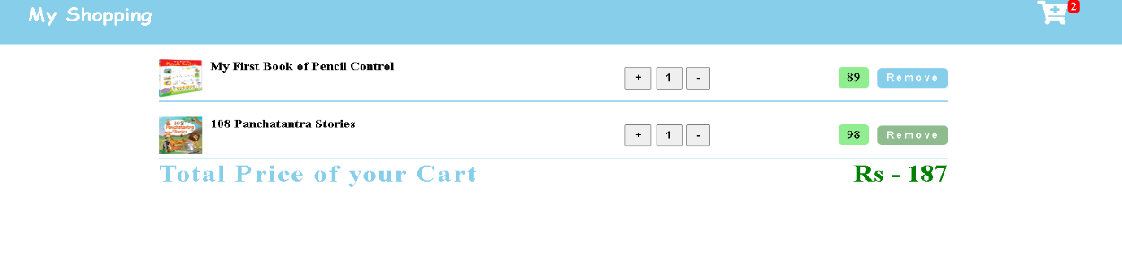

1. **Widget/Algorithm Used In Task**

**Technologies Used**

* **React**
* **React Functional Components**: Modular structure for Navbar, Amazon, Cart, and App components.
* **React Hooks**:
* useState: Manages application state, including the cart, item quantities, and warning notifications.
* Fragment: Simplifies grouping multiple elements without adding extra nodes to the DOM.
* **Conditional Rendering**
* Dynamically switches views between the product listing (Amazon) and shopping cart (Cart) using React's conditional rendering based on the show state.
* **CSS Styling**
* Custom styles (amazon.css) for a responsive and visually appealing UI.
* Warning messages styled to provide immediate feedback to the user.
* **Event Handling**
* **Add to Cart**: Button clicks trigger handleClick to add items while ensuring no duplicates.
* **Update Quantities**: The handleChange function adjusts item quantities and ensures consistency.
* **Sub-Technologies Used**
* **JavaScript Array Methods**
* forEach: Checks for duplicates in the cart.
* spread operator (...): Adds new items to the cart while preserving the existing state.
* **Timeout Functionality**
* setTimeout: Automatically hides warning messages after a specified duration.
* **Dynamic State Updates**
* Real-time updates ensure the cart reflects changes without page reloads.
* .